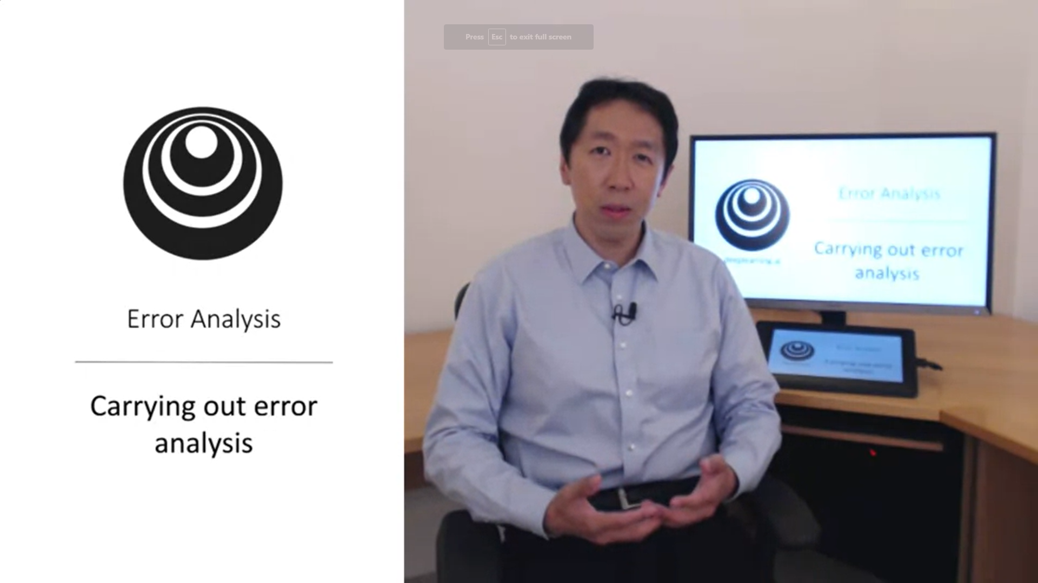

If the learning algorithm is not yet at the performance of a human you can carry out error analysis. This means manually looking at the errors the algorithm makes.

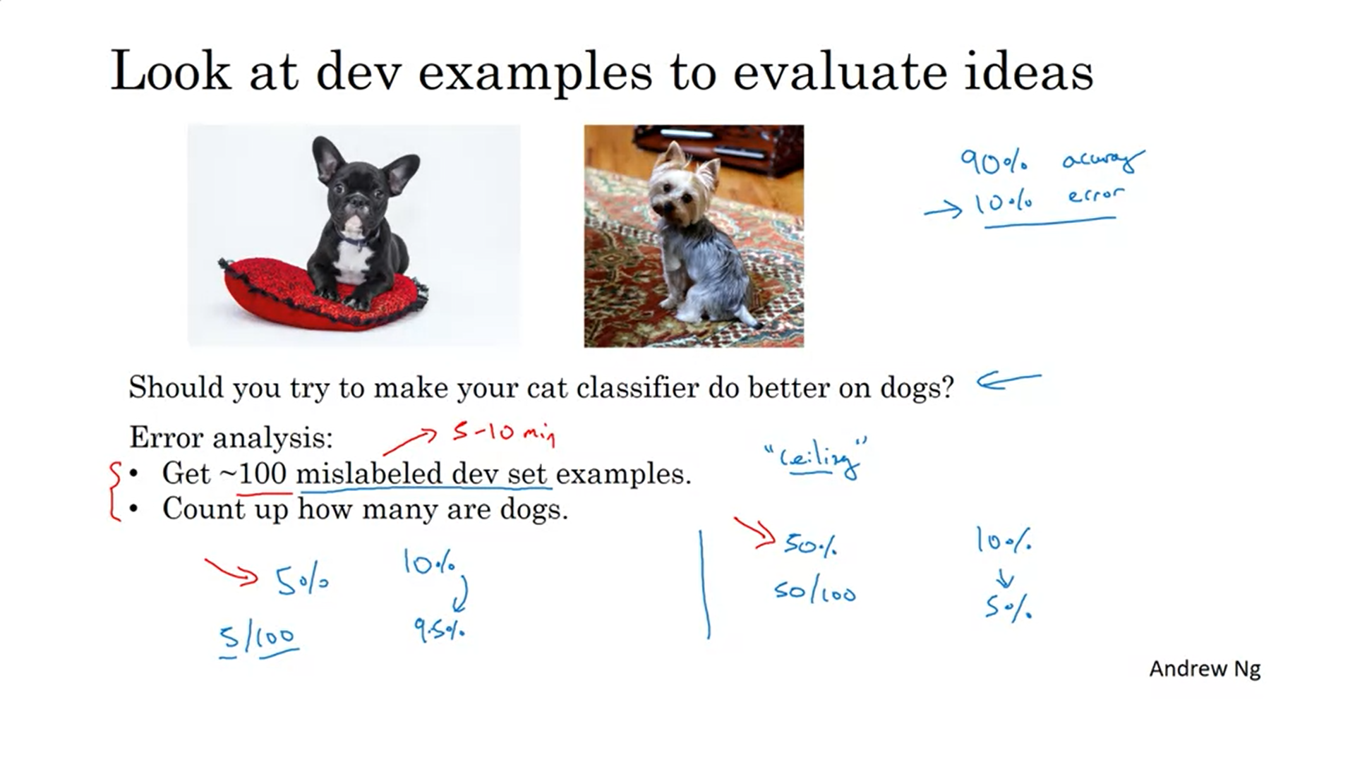

Example: cat classifier also detects certain dog breeds.

First question to ask: Is it worth the effort to tackle certain errors.

If 5% of 100 mislabeled dev set examples are dogs then correcting for this error (even if you can completely eradicate it) will only help you to get 5/100 correct -> ceiling for upper bound.

If 50% of the mislabeled examples are dogs then you can spend much more time on fixing this error.

In applied deep learning some “hand-engineering” like this is really useful.

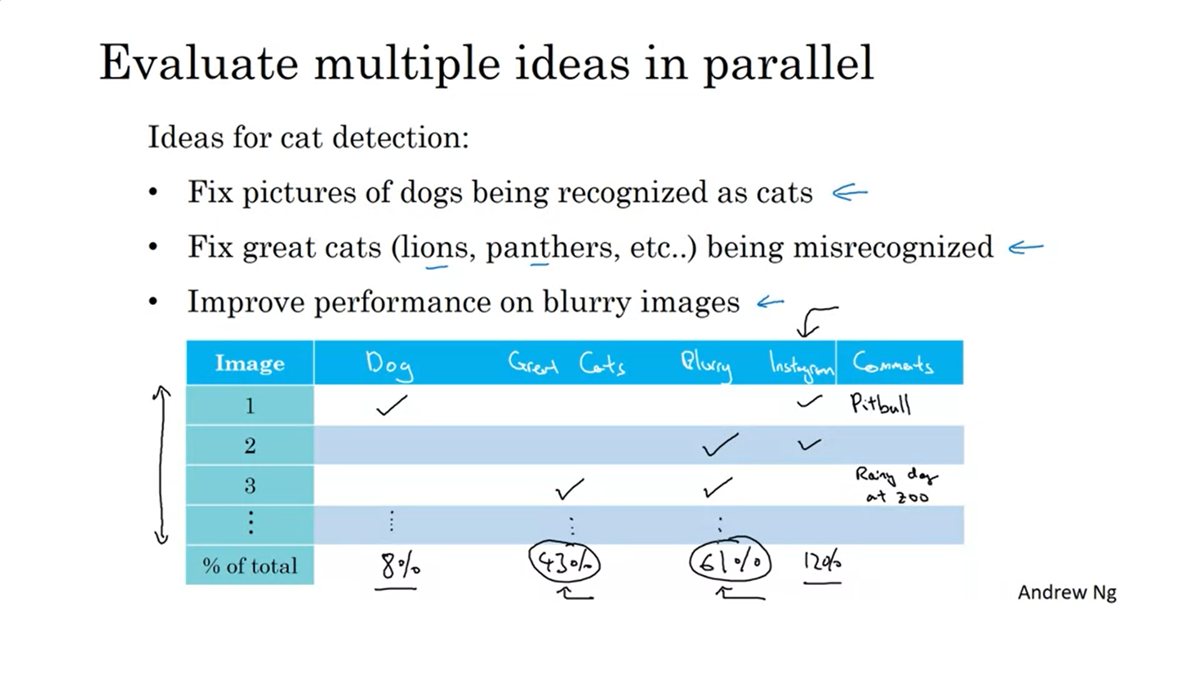

You have several ideas to improve. Which ones to pursue? Create a spreadsheet table!

It is ok to add another column part way through the process.

The conclusion of this exercise is an estimate where you can achieve a lot of improvement.

As you do error analysis, you will notice some mislabeled examples. What to do about them?

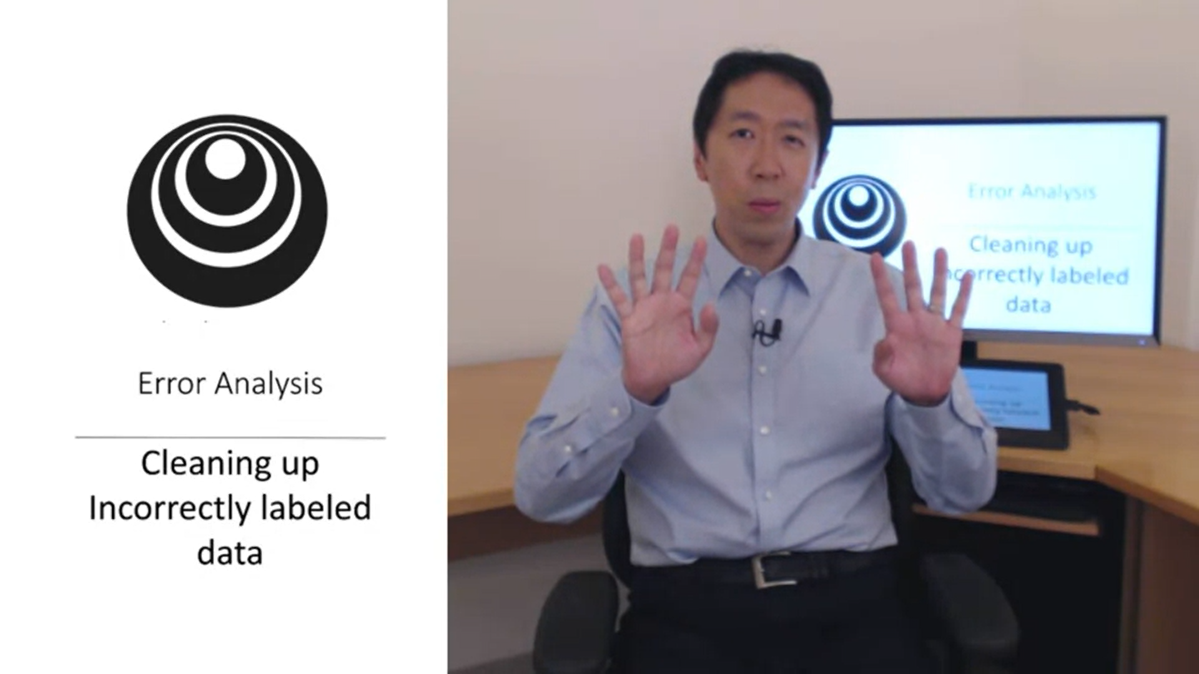

Is it worth to fix the labels?

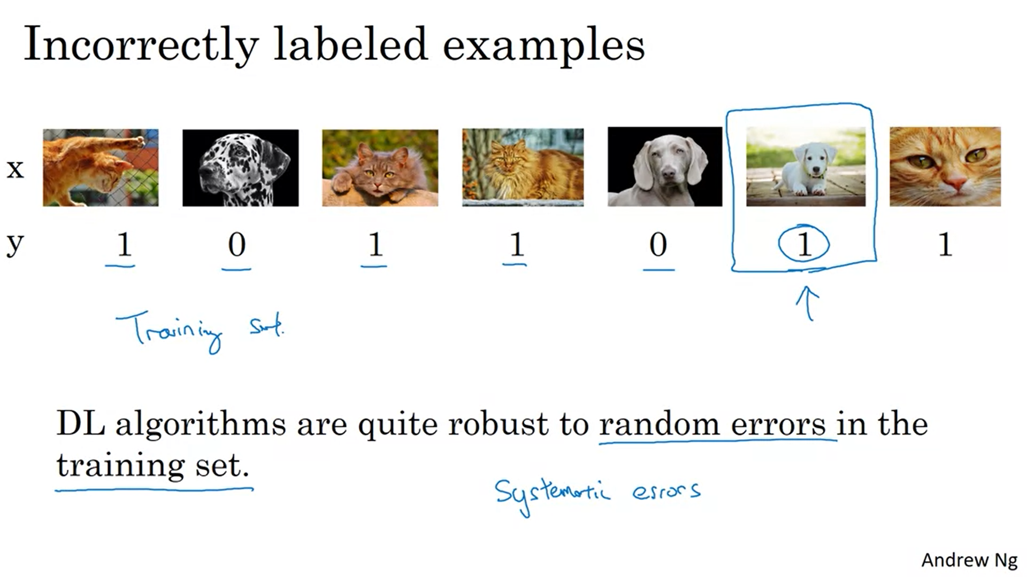

If the errors are reasonably random it is probably ok to just leave them as they are (so lang as the total dataset is big enough and the ratio of mislabels not too big).

Systematic errors are a problem!

This refers to the training set so far. How about the dev and test sets? Add one column to the error analysis.

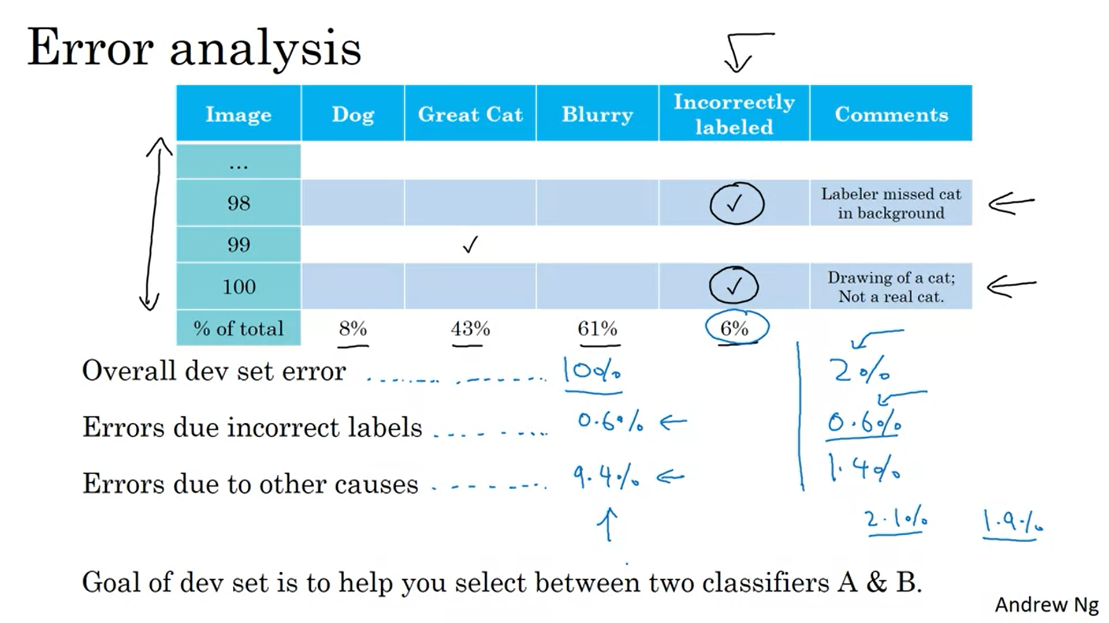

Maybe sometimes the algorithm’s prediction differs from the label because the label is wrong. Is it worthwhile to fix these labels?

Andrew suggests to do this if it makes a significant difference to evaluate your classifiers. If not then not. He will look at the above 3 numbers. Look at the ratio of incorrectly labeled errors compared to all errors.

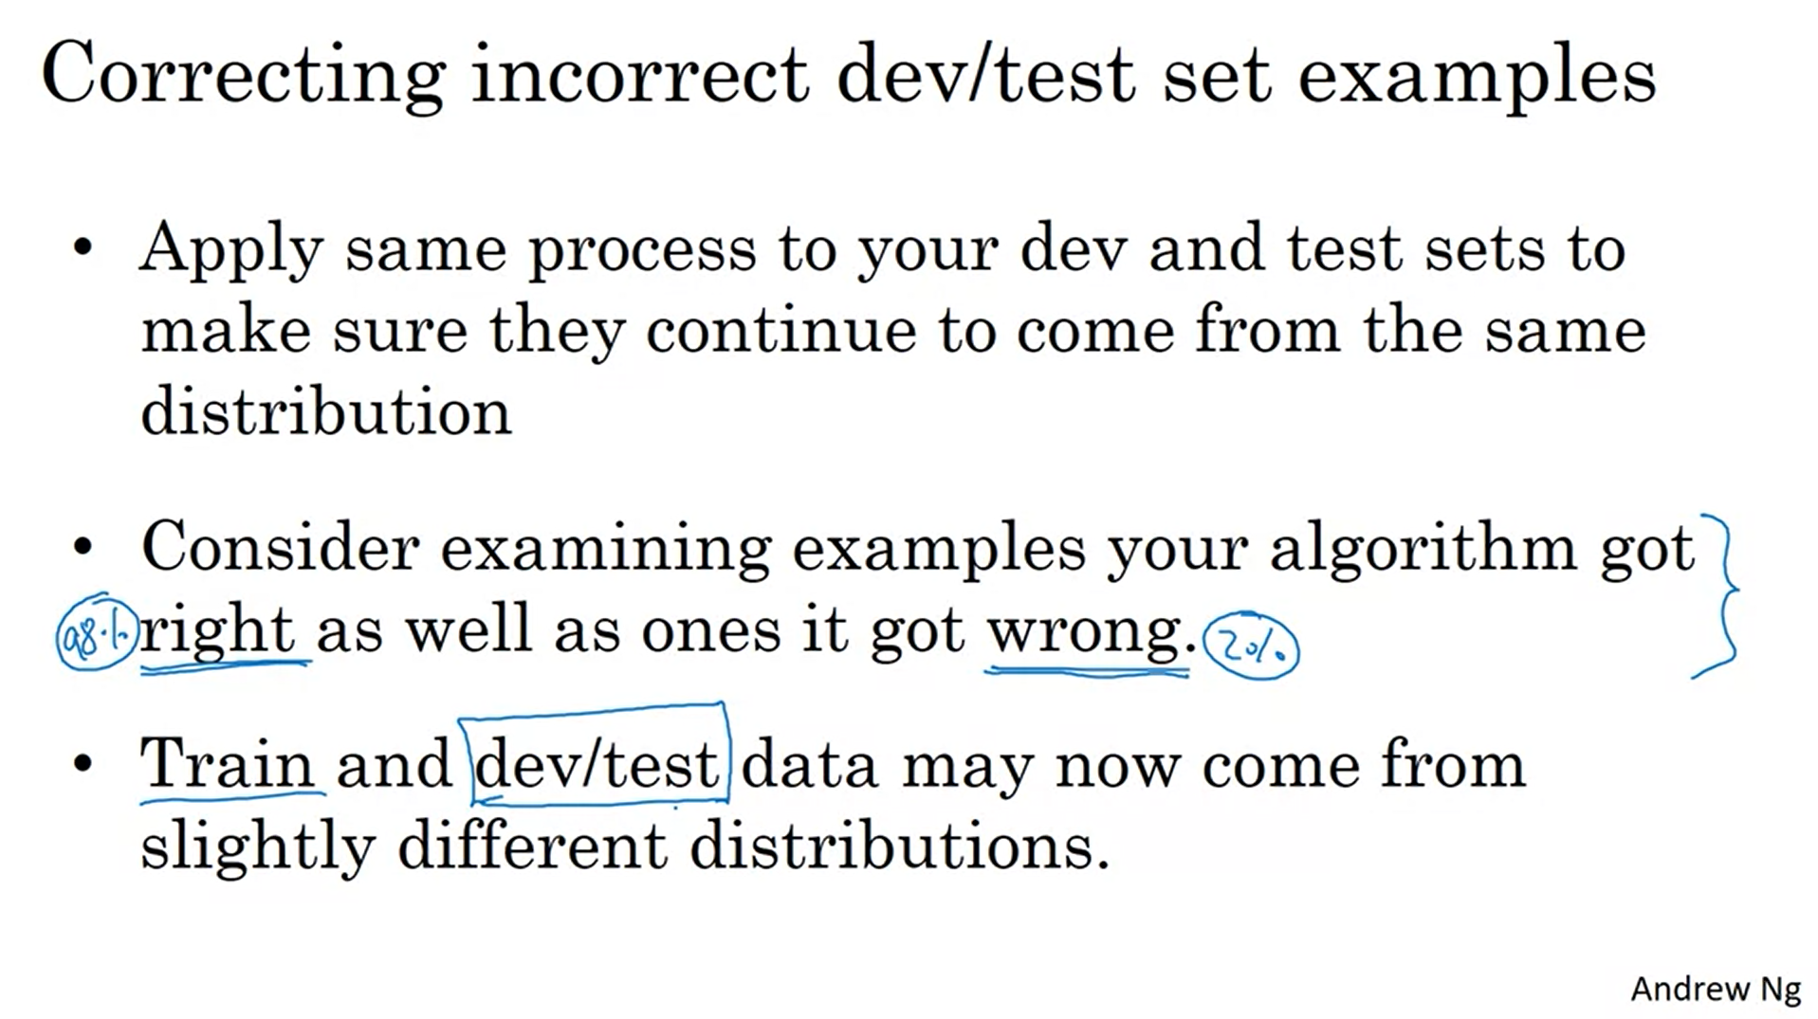

If you fix the dev set also fix the test set!

It is easy to look at the examples that the algorithm got wrong but also look at the ones that it got right (otherwise it will be biased).

You may or may not apply the same process in the training set. It is ok to not do it for the training set. Learning algorithms are quite robust to the training set coming from a bit a different distribution.

Do not be reluctant to manually look at the errors! Andrew still does that himself in the projects he leads.

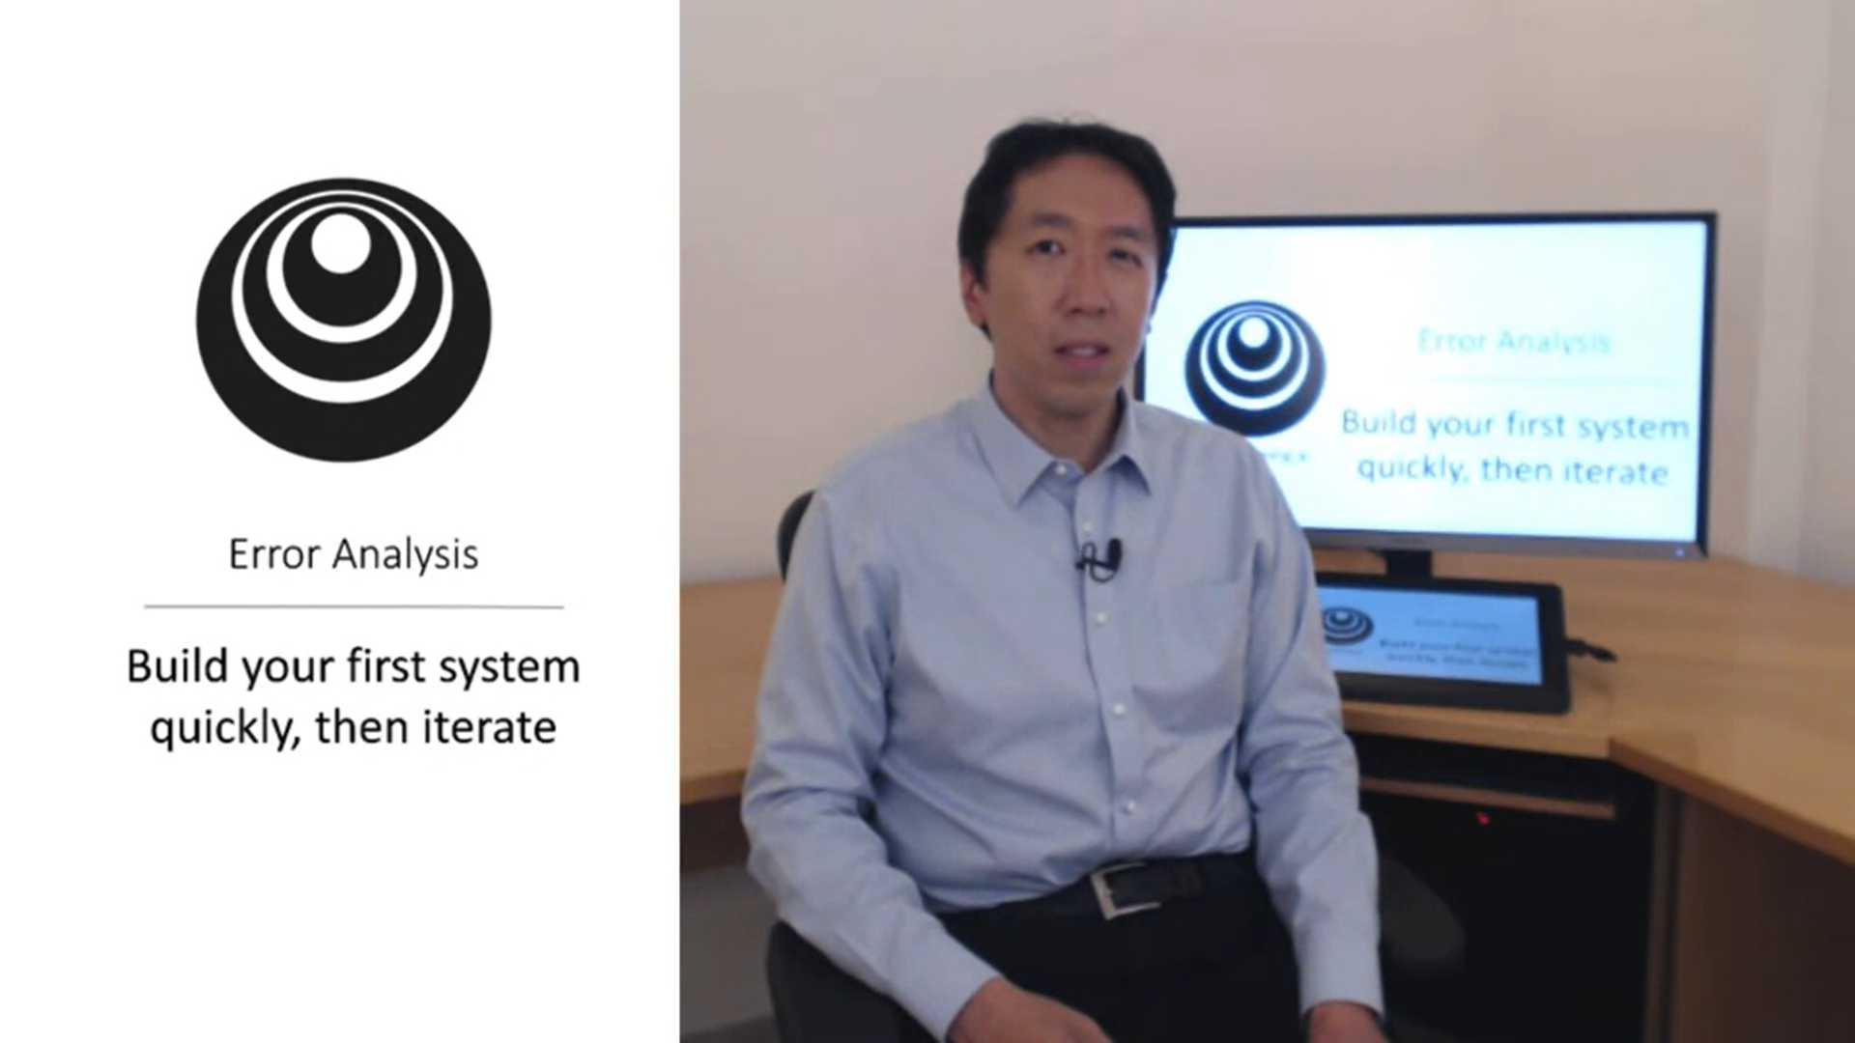

When you are building a new system.

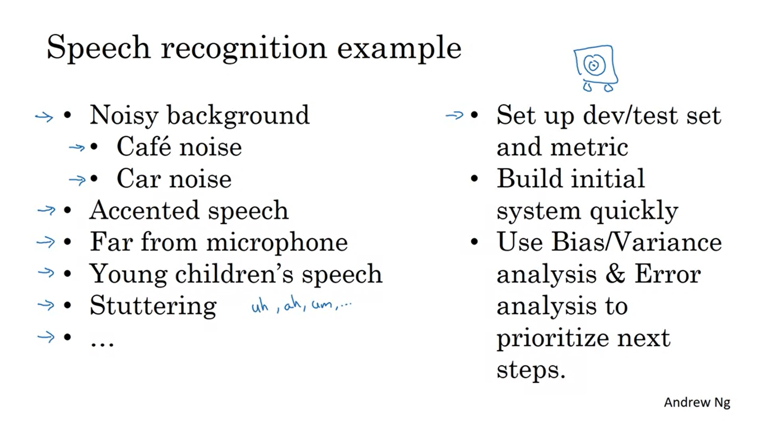

How to pick what to focus on? By iterating fast you can find out what is worth spending time on.

If there is a large body of academic literature that you can draw on it is ok to start a bit more complex (e.g. face recognition).

If you tackle a new problem for the first time do not overthink it but build quickly. On average Andrew has seen a lot more people overthinking their solutions than building something too simple.

The assumption for this is that your goal is to build something that works (rather than to invent the next breakthrough ml algorithm).

